# **LINUX — COMMANDS → L1 — — — — — — — — — — — —**

# **I — SYSTEM_ COMMANDS → → → →**

--------------------------------------------------------------------------  
# sudo -i --> Login as root user   
# exit --> Exit from current user  
# whoami --> Which user logged_in  
# pwd --> Current Working Directory  
# cd --> Change Directory  
 # cd .. -> Go back previous directory  
 # cd ../.. -> Go back 2 previous directory   
# ls --> List Files / Directory in current path  
# lshw --> List hardware configuration information  
# date --> View date  
# timedatectl --> View time & Date   
# hwclock --> Display Hardware Clock  
# uname -a --> Displays system information: kernel version, machine type, and more. ( uname -a , -r , -v , -m )  
# cal --> Calander   
# whoami --> Displays the username of the current user  
# clear --> Clear the screen  
# uname -a,-r, --> Displays the Linux infromation  
# uptime --> Shows how long system is running  
# last reboot --> List system reboot history  
# hostname --> Shows the system hostname  
# hostname -i --> Show the IP address of System  
# shutdown now --> Shutdown my system / server  
# finger username --> Displays information about a user  
# top , htop ,btop--> View the running process  
 * kill -9 -> to kill the running processor forcefuly  
 * kill -15 -> to kill the running processor properly  
# ps -ef --> to view the running processor  
 # ps -ef | grep ec2-user -> to view the particular processor  
# cat /proc/cpuinfo --> CPU info  
# cat /proc/meminfo --> Memory Info  
# history --> View history  
 # HISTTIMEFORMAT="%Y-%m-%d %T " --> View complte history   
 # history -c --> Delete all command in history  
 # history -d 32,26.02 --> Delete particular command in history  
 # history then # !10 --> Run a command again in history list

# **I I — DIRECTORY / FILE _ COMMANDS → → → →**

-------------------------------------------------------------------------  
# mkdir Dir_1 --> Create a directory  
 # mkdir Tester{0..5} => Create 6 dir at time  
 # rmdir Tester{0..5} => Delete 6 dir at time.  
# cp -r Dir_1 Dir_2 --> Copy Source _ Distination_Directory   
# mv Dir_1 Dir_2 --> Move Source _ Distination_Directory   
# diff Dir_1 Dir_2 --> Compare two DIRS and display differences.  
--------------------------------------------------------------------------  
# touch File_1 --> Create a File without content  
 # touch Developer{0..5} => Create 6 dir at time  
 # rm -f Developer{0..5} => Delete 6 dir at time  
# echo " My linux commands " > testing.txt --> Create a file with content  
# cat > File_2 --> Create a file with content   
# cp File_1 Dir_2 --> Copy Source files _ Distination_Directory   
# mv File_2 Dir_2 --> Move Source files _ Distination_Directory  
# diff File_1 File_2 --> Compare two files and display differences.  
---------------------------------------------------------------------------   
# tail -f /var/log/syslog --> Check System logs @ Run_time ( IMPORTANT REAL TIME )  
# less updates.txt <<< /// >>> more updates.txt => content page by page view  
# head -10 updates.txt --> Shows first 10 lines of file   
# tail -10 updates.txt --> Shows last 10 lines of file

# **III — VI / VIM _ EDITOR → → → → →**

• # :wq --> Save & Quit  
• # :q! --> quit force without saves  
• # 3yy --> Copy 3 lines <<< /// >>> p => Paste a lines  
• # dd --> delete single line ,3dd => delete 3 lines, x = backspace  
• # :%d --> Delete all lines  
• # :set nu / :set nonu --> Numbers settings  
• # :2 --> Navigate that line  
• # u --> Undo   
• # Ctrl+r --> Redo   
• # / = Search, downside >>> "n" upside >>>"shft+n" → next and next   
• # :%s/uma/umasankar/g or gc => Search & Replace all in text file completely.  
• # g + U + w & g+u+w => change uppercase to lower case  
• # g + U + G & g + u + gg => all line uppercase & Lowercase  
• # cntrl+z <<< /// >>> fg --> Minimize and Maximize editor ( Must save& Exit before close terminal )   
• # gg --> switch to the first line  
• # shift + g --> switch to the last line

# **IV — FILE COMPRESSION / TRANSFER_COMMANDS**

# scp file_1 ec2-user@1.1.1.1 /home/ec2-user --> File transfer Server_1 to Server_2  
# wget <URL> --> Download any tool / file from internet  
# sudo curl -O [link] --> Transfer data to or from a server to Servers  
# tar -cvzf [file/directory] --> Archive [file/directory] using TAR_FORMAT  
# tar -xvzf [file/directory.tar] --> Un-Archive [file/directory] using TAR_FORMAT  
# gzip [file_name] --> Archive [file/directory] using gzip_FORMAT  
# gunzip [file_name.gz] --> Un-Archive [file/directory] using gzip_FORMAT

# **V — NETWORKING / SSH _ COMMANDS → → →**

# nmtui --> Change Host_name  
# ifconfig --> Show all IP address ( IP_V4 , IP_v6 )  
# ping [remote_host] --> Ping Servers ( communication_check )  
# netstat -pnltu --> Check TCP / UDP lister's port's   
# host [domain_name] --> Check Domain_IP  
# hostname -i --> Show local IP's address   
# nslookup [domain_name] --> Receive information about an internet domain  
  
--------------------------------------------------------------------------------  
  
# ssh -i ec2-user@1.1.1.1 --> Communication establishment SERVER to SERVERS  
# ssh -keygen --> Creating Key_pairs  
# ssh -p "1111" ec2-user@1.1.1.1 --> Connect to the host using a particular port  
# sudo systemctl start sshd --> Start sshd ( Demon_process )

# **VI — DISK_COMMANDS → → → →**

# df -hi --> Check free and used space on mounted systems  
# lsblk --> List Block   
# du -ah , -sh --> See disk usage for all filesand directories.  
# free -h --> Display free and usedmemory  
# fdisk -l --> Display disk partitions  
# lshw --> List Hardware info

# **VII — BOOTSTRAP → → → APACHE_INSTALLATION**

1, Redhat_LINUX -->  
---------------  
#! /bin/bash  
sudo yum install httpd -y  
systemctl start httpd  
sudo yum update  
  
2, Amazon_Linux -->  
---------------  
#! /bin/bash  
sudo yum install httpd -y  
systemctl start httpd  
sudo yum update  
  
3, UBUNTU_LINUX -->  
---------------  
#! /bin/bash  
sudo apt-get update  
sudo apt install apache2 -y  
systemctl start apache2  
sudo apt-get update

# **VII — Encrypt/decrypt via Linux_command**

# echo "Sankar" -> Encrypt this variable / Password   
# echo -n "Sankar" | base64 -> En encrypted  
# echo -n "uty54yt55t5t5t6" | base64 - decode -> Decrypted

# **VIII — File / DIR CHANGE PERMISSION_ COMMAND**

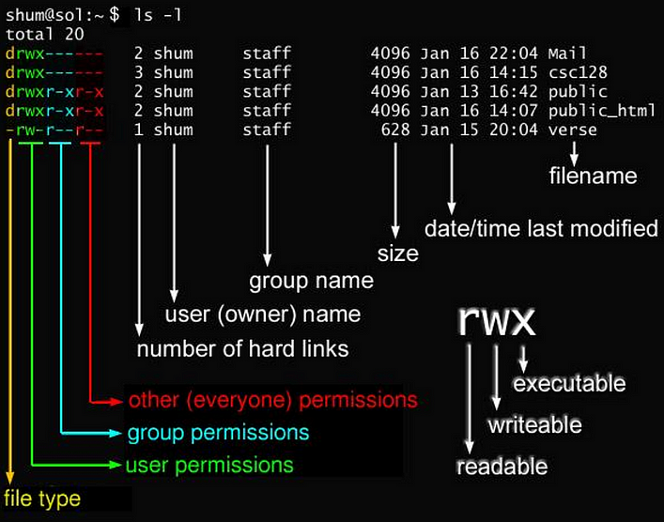

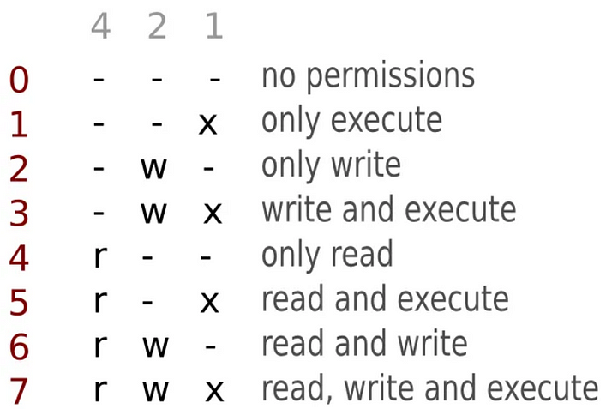

* R - read -> 4  
* W - Write -> 2  
* X - excute -> 1  
  
# ls -larth --> List files / Dirs  
# chmod 754 file_name --> Change permission File_name   
# chmod U=rwx, G=rx-, O=-r- file_name   
  
# chmod 777 Sathish => Set full permission ( File / Directory )

# **IX — File / DIR CHANGE PERMISSION_ COMMAND**

# id --> See details about theactive users  
# last --> Show the last system logins  
# who --> Display who is currently logged into the system  
# sudo useradd sankar_1 --> Create new user  
# passwd sankar_1 --> Create Password   
# finger ubuntu --> Show user information  
# su - sankar_1 --> Login as sankar_1 ( USER )   
# sudo userdel sankar_1 --> Delete user

# **X — KEY_BOARD SHORTCUTS → → →**

# Ctrl + C --> Kill running process  
# Ctrl + Z --> Stop the current process  
# Ctrl + W --> Cut one word before the cursor  
# Ctrl + U --> Cut part of the line before the cursor  
# Ctrl + K --> Cut part of the line after the cursor  
# Ctrl + Y --> Paste from clipboard  
# Ctrl + R --> Recall the last command that matches the provided characters.  
# !! --> run again last command   
# exit --> Log out of the current session

/etc/passwd - file contains user details as a single line with seven fields

Lslogins - command displays information about known users in the system, including details such as the username, UID (User ID), GID (Group ID), home directory, shell, and last login time.

/etc/shadow -

compgen -u